Lab 7 Report

1. Objectives
The purpose of this lab is to install and configure Istio on a Minikube Kubernetes cluster, deploy the Bookinfo sample application, expose it via an ingress gateway, apply routing rules, and visualize traffic using Kiali and Prometheus.

2. Environment Setup
Operating System: macOS Sequoia 15.7.1 (ARM64)
Platform: Minikube running on Docker Desktop
Kubernetes Version: v1.29.3
Istio Version: 1.28.0

3. Procedures and Observations
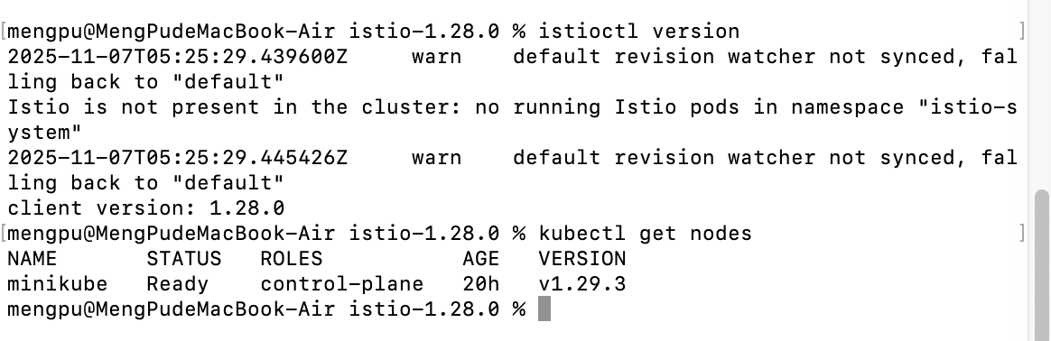
Figure : Verifying Istio CLI and Kubernetes node readiness.

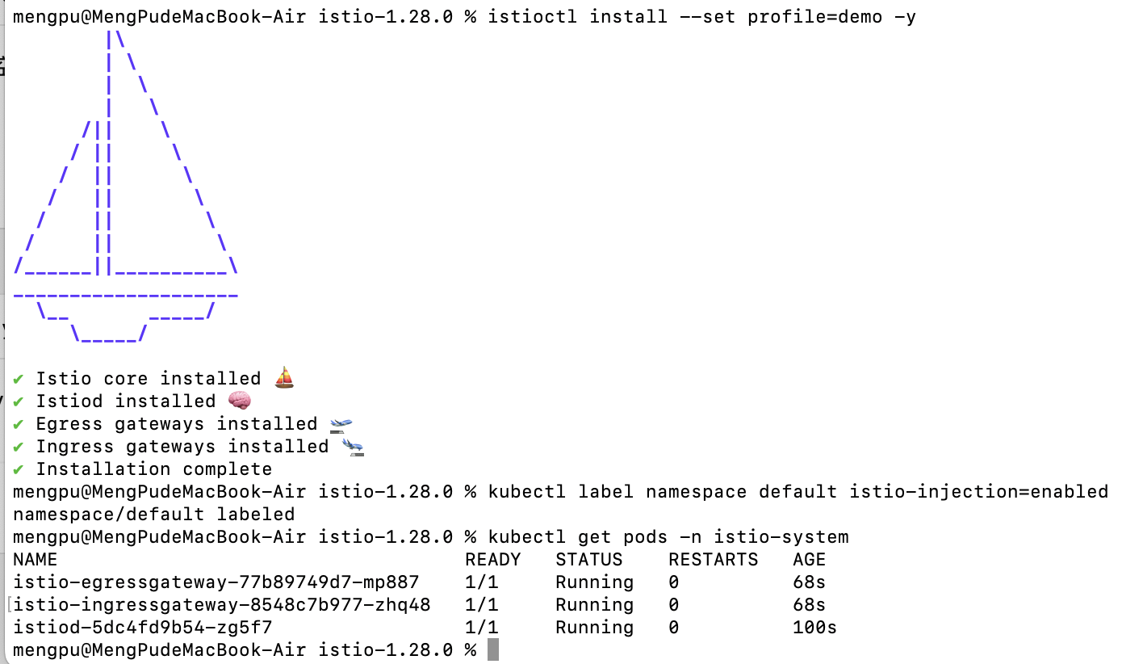
Figure : Install istio

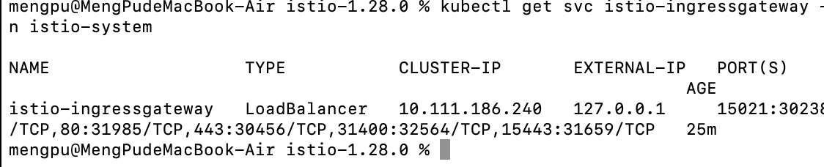
Figure : Checking Istio Ingress Gateway service and exposed ports.

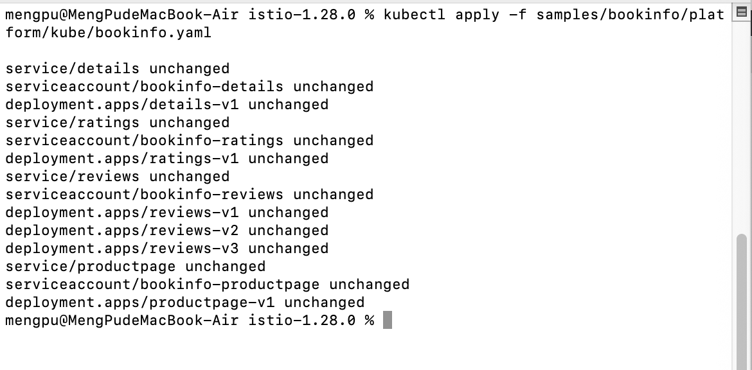
Figure : Deploying the Bookinfo sample application on Kubernetes.

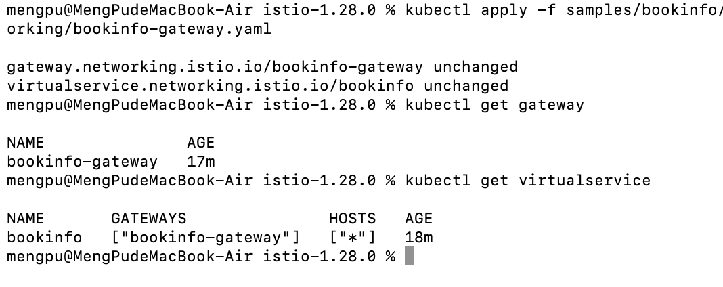
Figure : Creating Istio Gateway and VirtualService for Bookinfo routing.
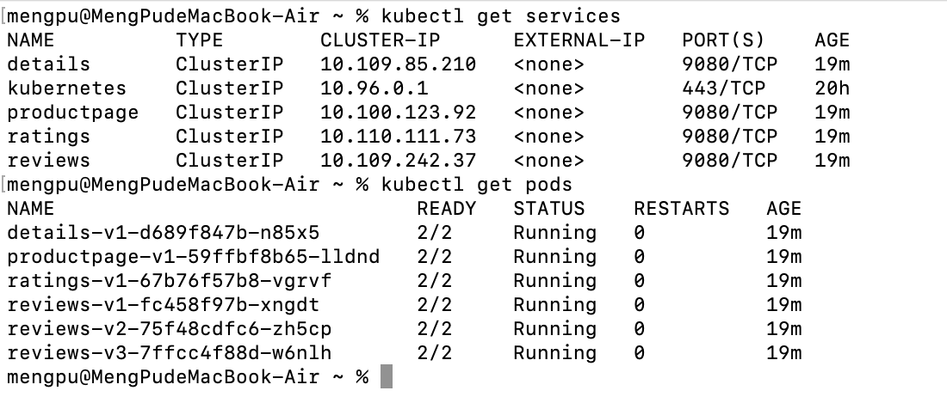
Figure : Verifying all Bookinfo services and pods are running correctly.

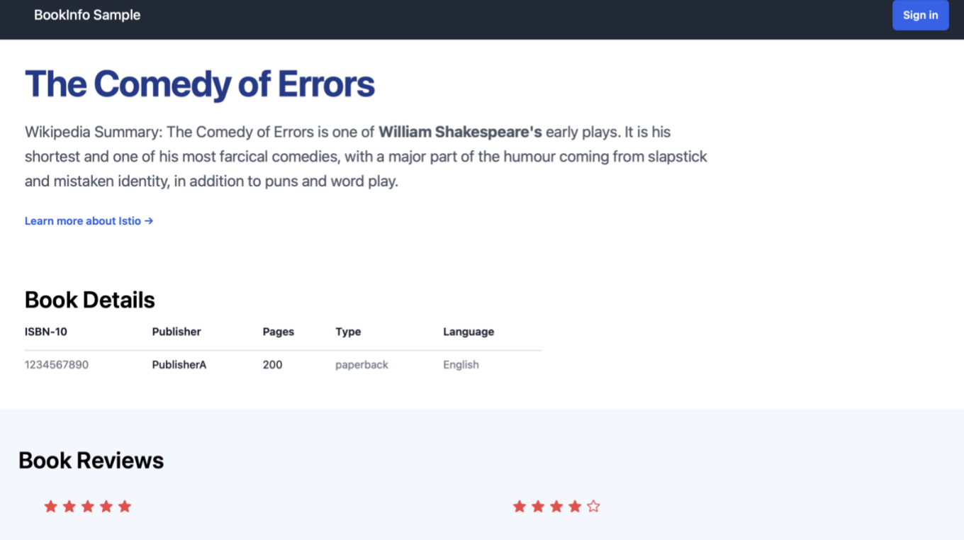
Figure : Accessing Bookinfo application webpage (initial version, no reviews shown).
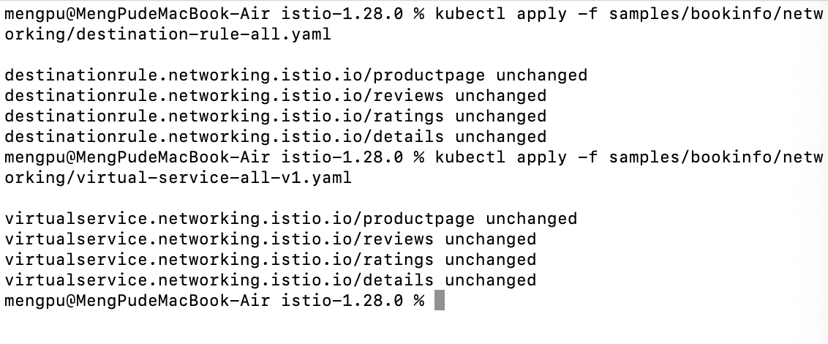
Figure : Applying DestinationRule and VirtualService configurations.

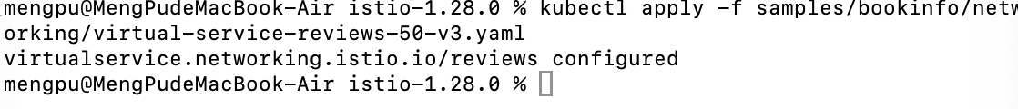
Figure : Applying version v3 routing rule for reviews service.
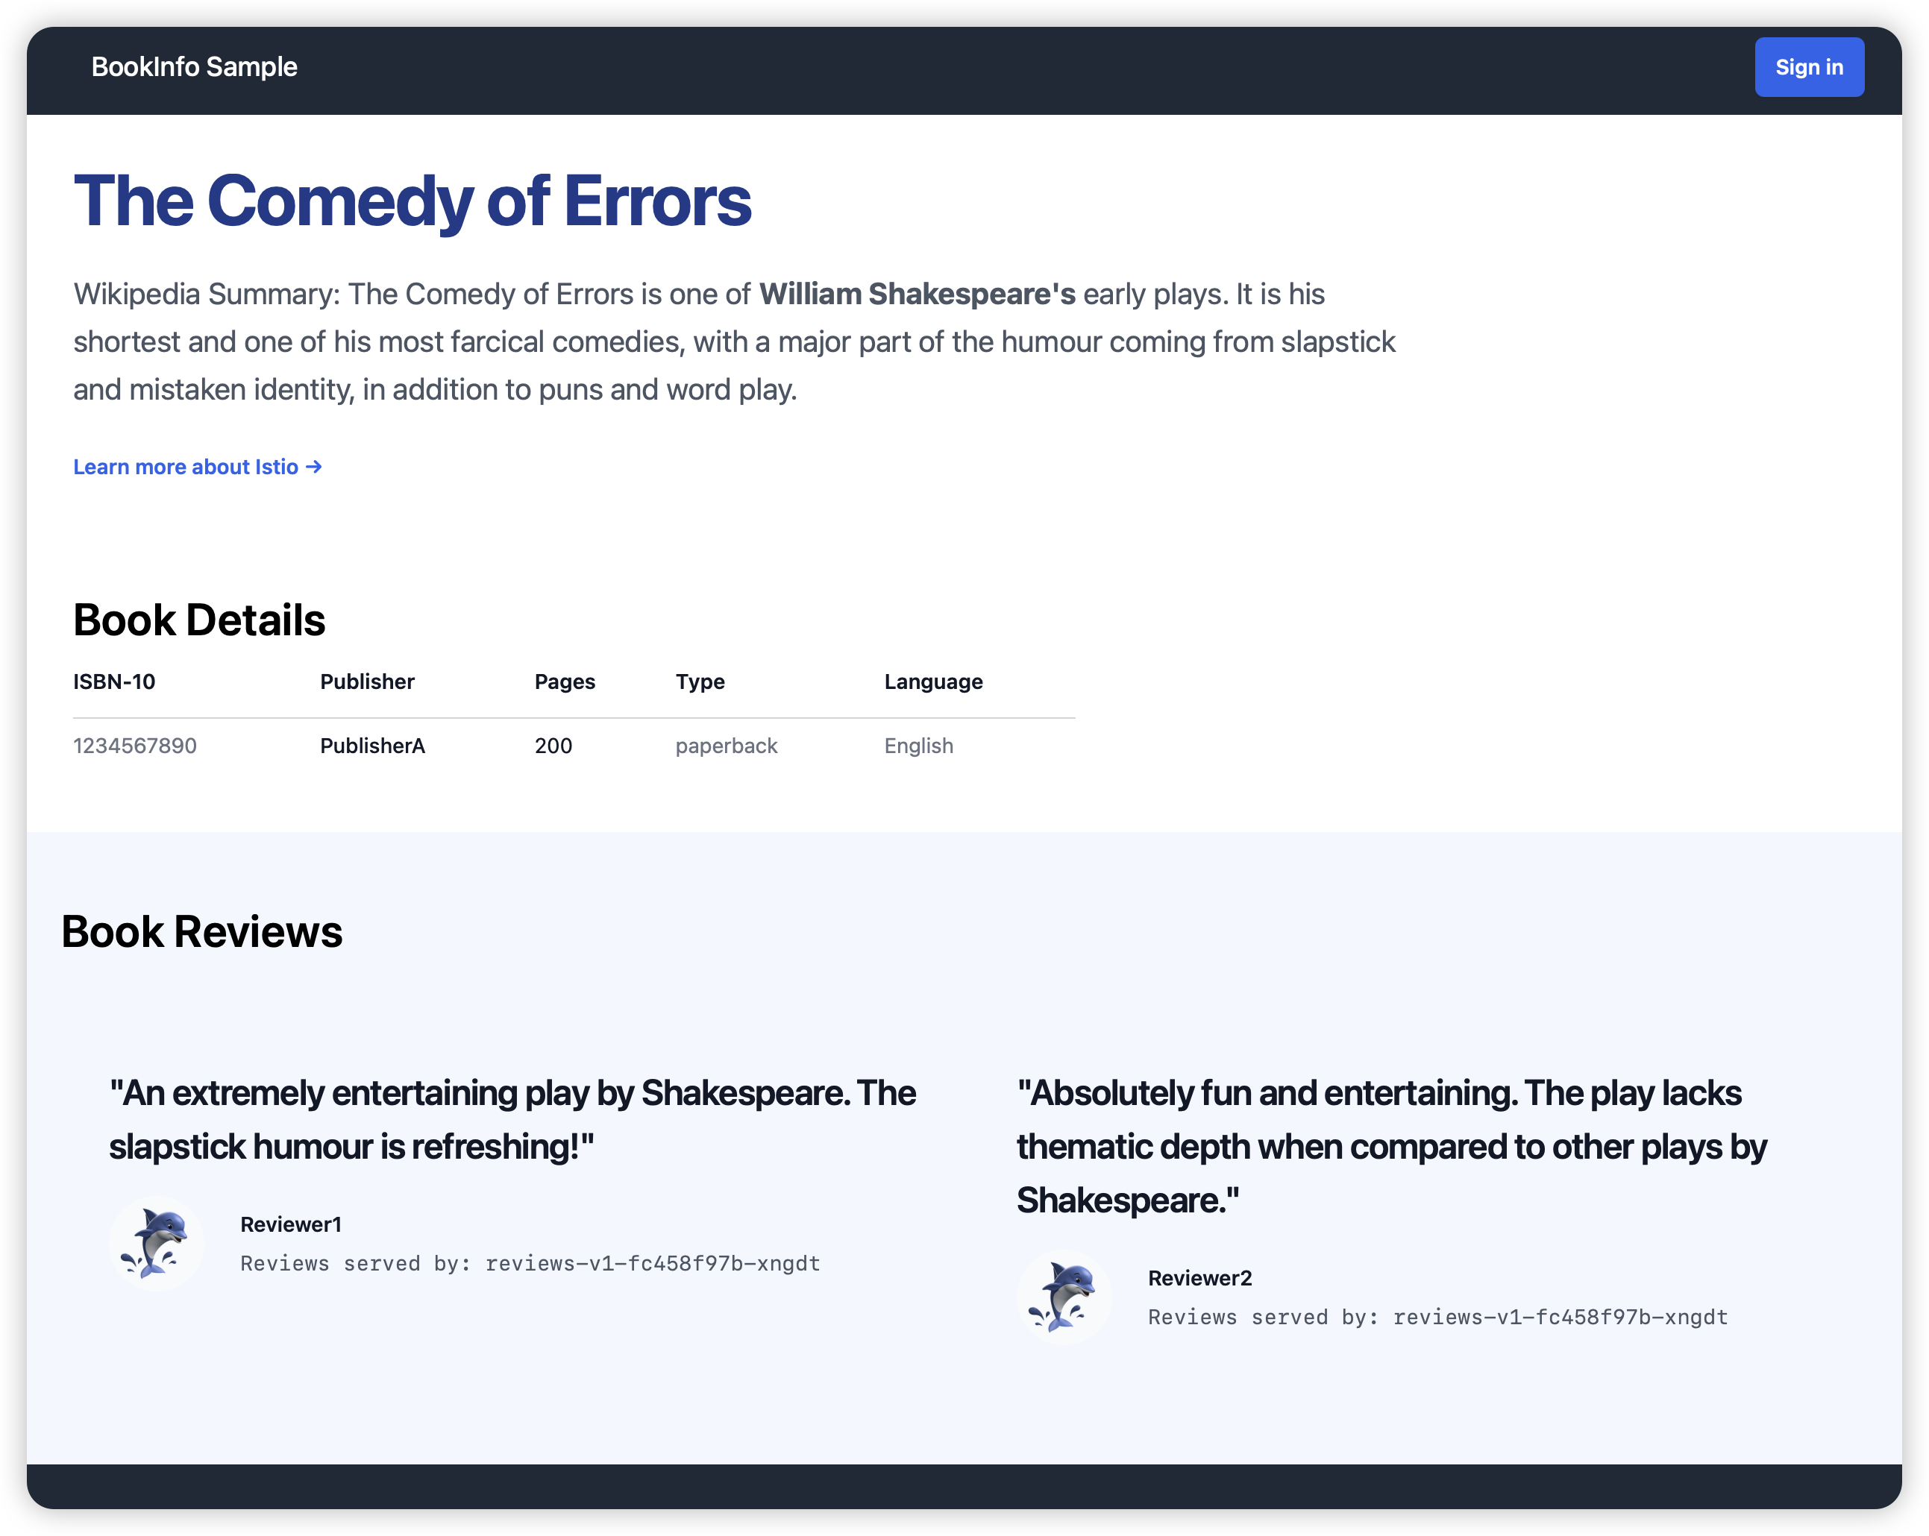
Figure : Bookinfo webpage showing mixed review routing behavior.

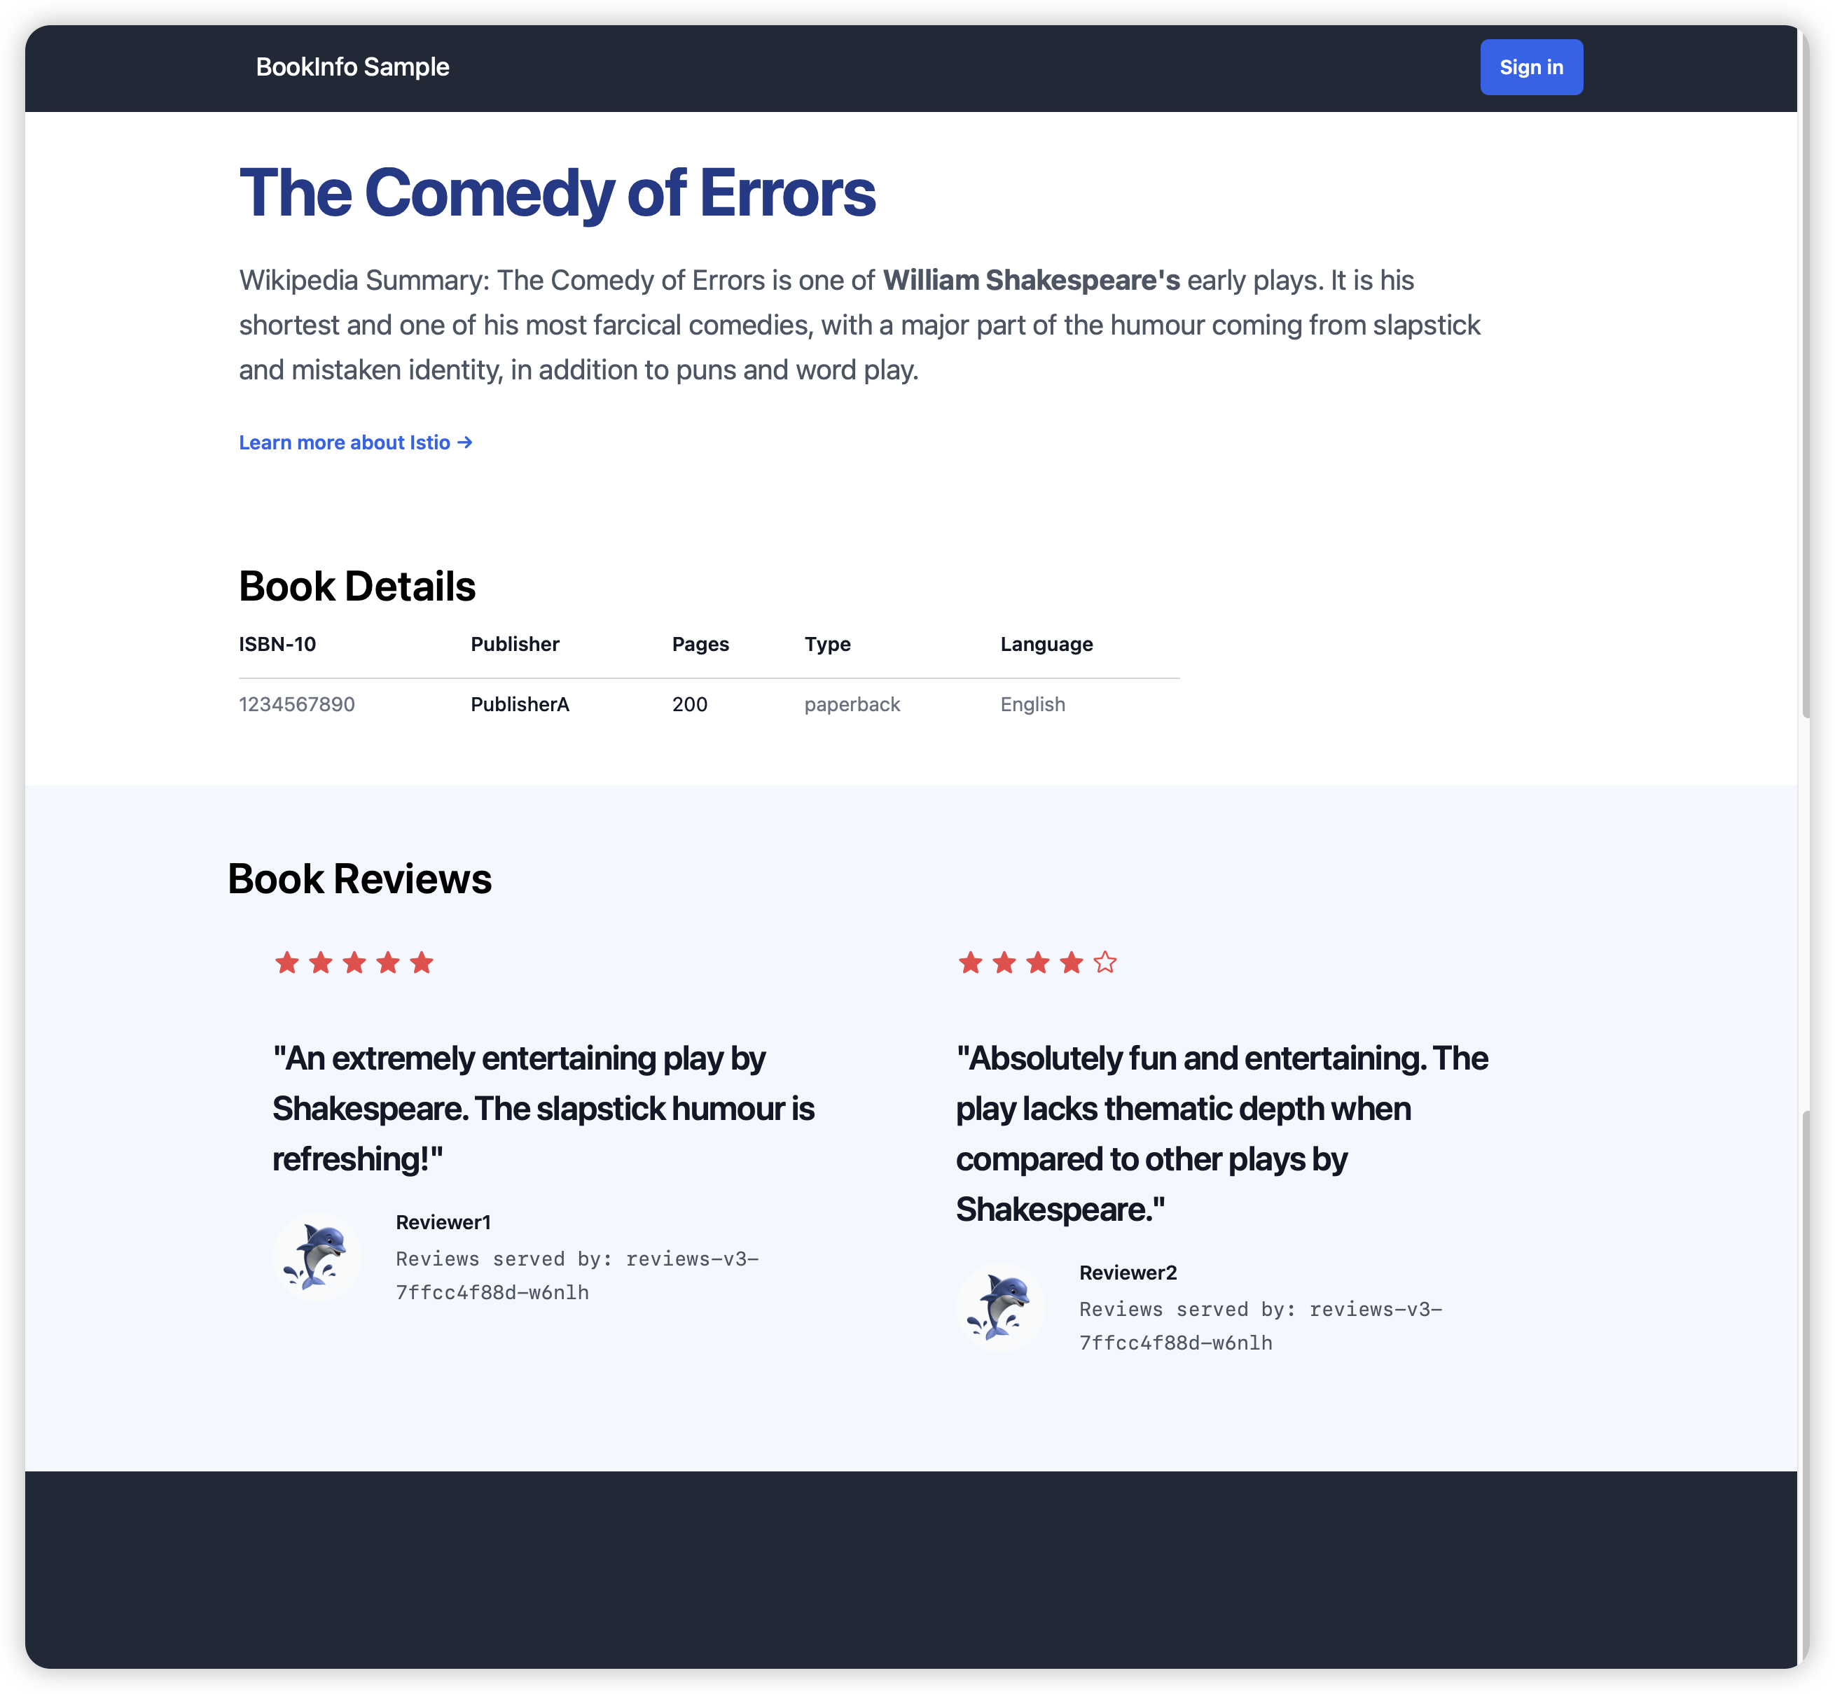
Figure : Bookinfo webpage showing v3 routing with star ratings.
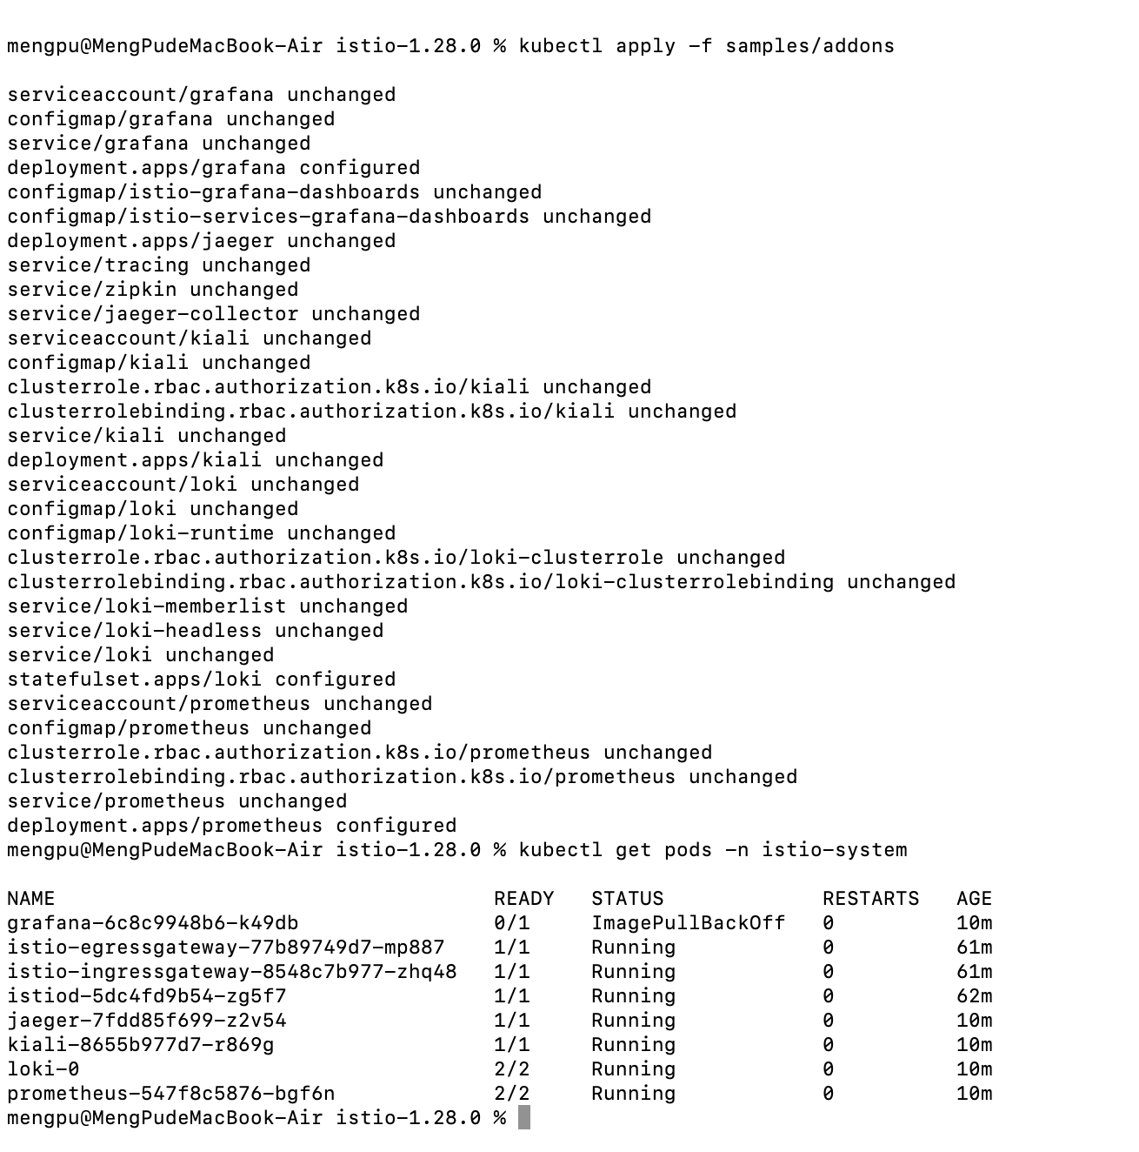
Figure : Deploying Istio Addons including Kiali, Grafana, and Prometheus.
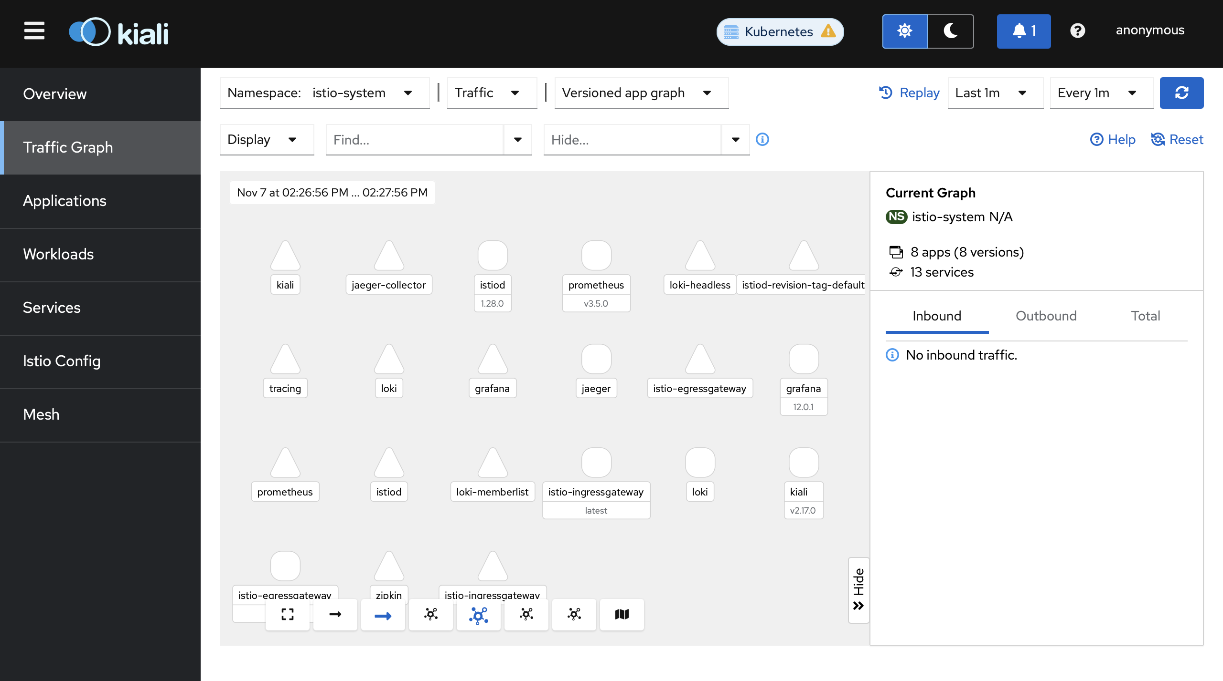
Figure : Kiali dashboard showing system namespace topology.

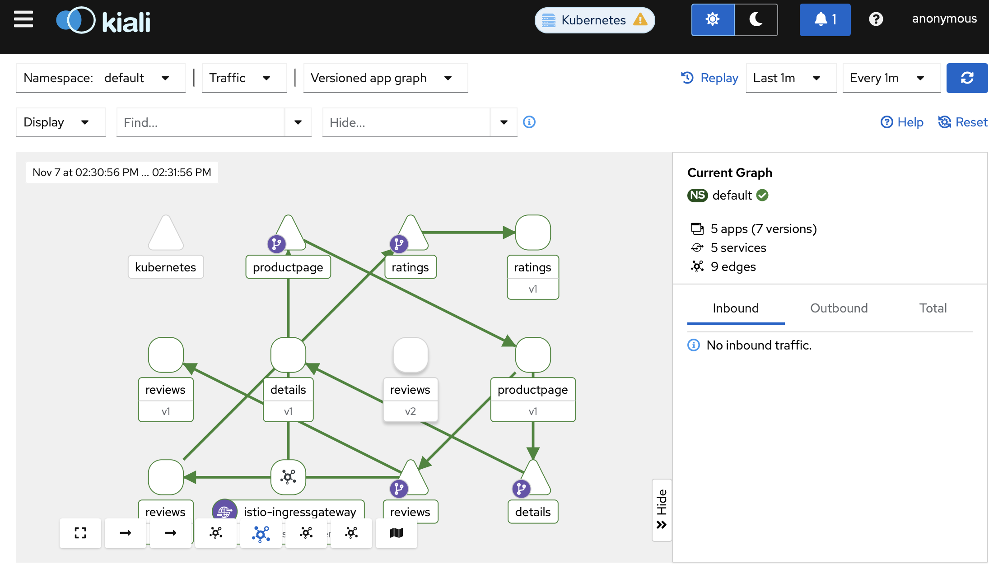
Figure : Kiali traffic graph visualizing Bookinfo microservice interactions.
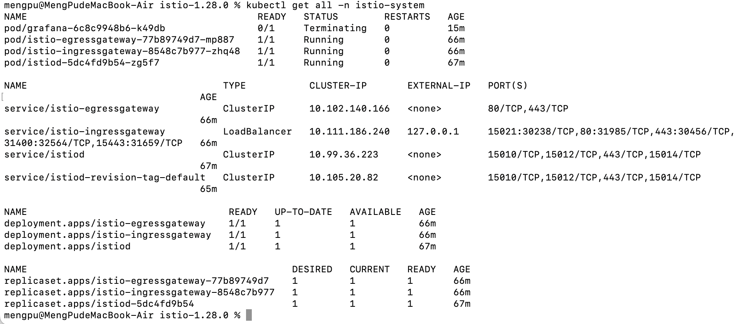
Figure : Cleaning up the Istio environment and removing resources.

4. Conclusion
The Istio service mesh was successfully installed and configured within a Minikube environment. The Bookinfo application was deployed, exposed through the Istio ingress gateway, and traffic routing rules were applied and observed using Kiali. This lab demonstrated microservice connectivity, observability, and routing control with Istio.

